Chapter 4, Problem 60.

For the circuit in Fig. 4.126, find the Thevenin and Norton equivalent circuits at terminals a-b.

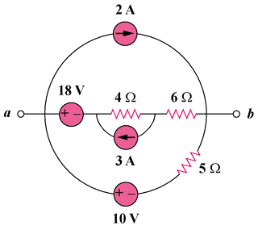

Figure 4.126
For Prob. 4.60.

